**SUPER MATERIALS COMPANY LIMITED**

1. **INTRODUCTION**

**Super Materials Company Limited** specializes in supplying raw materials, piping and fittings made by exceptional materials(Inconel, Incoloy, Monel, Hastelloy, Super Duplex, Duplex, etc.) using widely in the Oil & Gas, Aerospace, Chemical, Petrochemical, Automotive, Shipbuilding, Power Generation. Say NO to products originating from China and India, we have a strong network with renowned makers/manufacturers in EU and G7 group such as Austria, UK, US, Italy, Germany, Japan, etc. Super Materials Company Limited is confident to be a reliable supplier in Vietnam market regarding special raw materials, piping and fittings.

|  |  |
| --- | --- |
| Company name  Abbreviation  Address  Tax code  Phone  Fax  E-mail  Website | **SUPER MATERIALS ONE MEMBER COMPANY LIMITED**  SUPER MATERIALS CO., LTD.  201/15 Le Van Viet Street, Hiep Phu Ward, District 9, Ho Chi Minh City, Vietnam  0315502282  +84 98 9944 746  -  [sales@ss-materials.com](mailto:phunguyen@pgmaterials.com) (Mr. Nam)  [www.ss-materials.com](http://www.ss-materials.com) |
| Company logo | C:\3. Super Materials\1. Marketing\Logo\Logo PNG.png |

1. **PRODUCT**
   1. **Solid round bar**

Being used widely in the field of precision machining, solid round bar is the main form of raw material for fabricating various mechanical parts. Super Materials Co., Ltd. imports and distributes solid round bars made by special materials namely **Nickel Alloy** (alloy 200/201, 400, K500, C276, 600/601, 625/825/925, 718, L605, 602CA, etc.), **Titanium** (grade 1, 2, 3, 4, 5), **Stainless Steels** (Super Duplex UNS S32750/S32760/S39277, Duplex UNS S31803/S31254, 15-5PH/17-4PH, 9Cr, 13Cr/S13Cr, 904/904L, 321, 317, etc.), **Low Alloy** (4140, 4130, 4145/4145H).

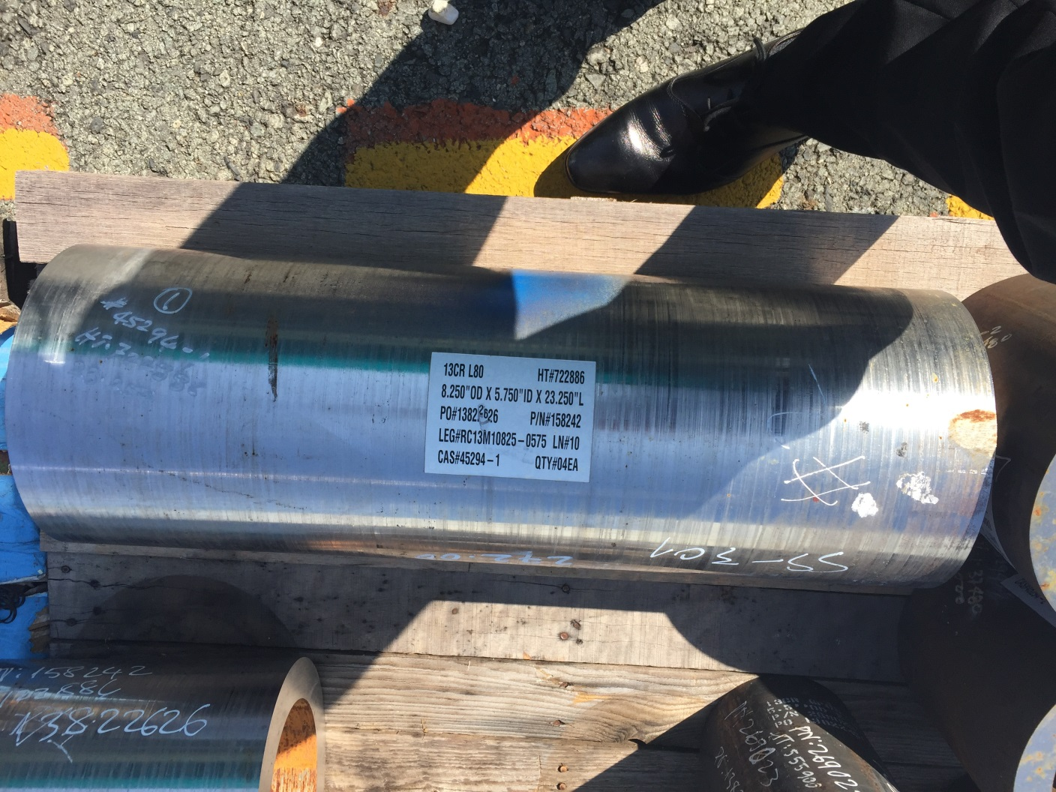

*Material 13Cr*

* 1. **Plate and sheet**

Besides solid round bar, raw materials in form of plate and sheet are also consumed considerably in the field of precision machining especially in production of flange, seal, gasket, steam/gas turbine and other high standard products using in Aerospace, Oil & Gas and Power Generation industry. With numerous years of experience importing special raw materials and steel products from countries in EU and G7 group, Super Materials Co., Ltd. affirms to bring customer high-quality plates and sheets comply strictly international standards with clear Certificate of Origin (CO) and Certificate of Quality (CQ). We provide plate and sheet made by **Nickel Alloy** (alloy 200/201, 400, C276, 600/601, 625/825/925, 718, 800H/800HT, L605, 602CA, Invar 36, etc.), **Titanium** (grade 1, 2, 3, 4, 5), **Stainless Steels** (Super Duplex UNS S32750/S32760/S39277, Duplex UNS S31803/S31254, 15-5PH/17-4PH, 904/904L, 321, 317/317L, 347/347H, etc.), **Low Alloy** (4140, 4130, 4145/4145H).

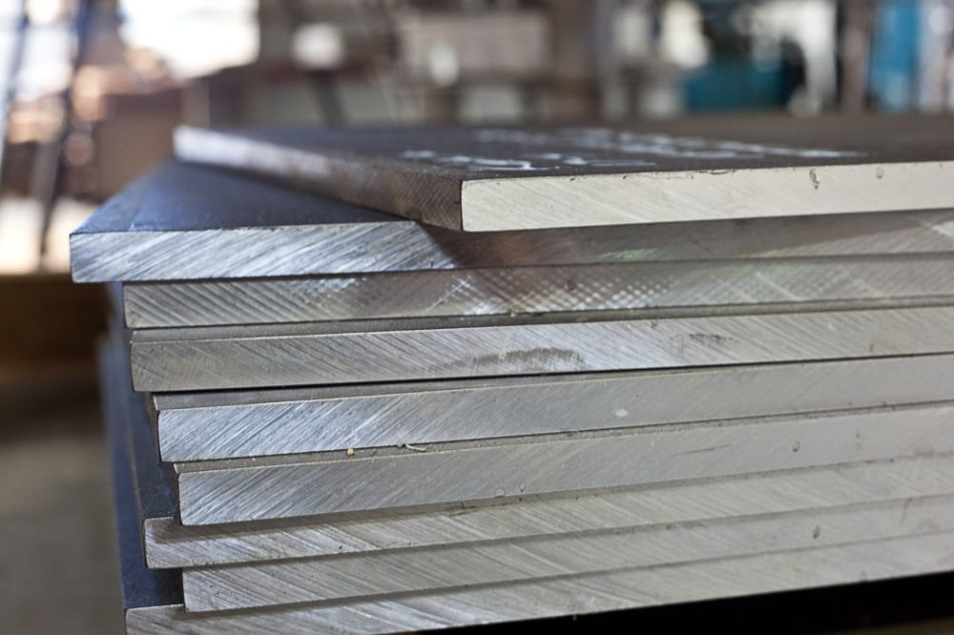

*Inconel 625 UNS N06625*

* 1. **Pipe**

Regarding pipe products, most of them are used to manufacture heater, heat exchanger, desalination equipment, etc. in Shipbuilding, Oil & Gas and Petrochemical industry. Super Materials Co., Ltd. asserts itself as reliable supplier of pipe products with various dimension and made by special materials such as **Nickel Alloy** (alloy 200/201, 400, C276, 600/601, 625/825/925, 718, 800H/800HT, etc.), **Titanium** (grade 1, 2, 3, 4, 5), **Stainless Steels** (Super Duplex UNS S32750/S32760/S39277, Duplex UNS S31803/S31254, 15-5PH/17-4PH, 904/904L, etc.).

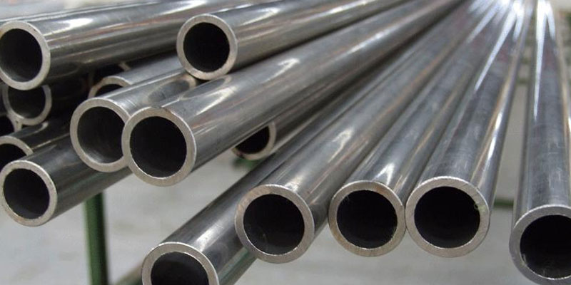

*Pipe 904L*

* 1. **Fitting**

Not only supplying special raw materials in form of round bar, plate/sheet, and pipe, Super Materials Co., Ltd. also imports and distributes fittings and pipe accessories for projects. Fittings include flange, seal, gasket, elbow, tee, olet, etc. We focus on products originating from countries in the EU/G7 group and made by special stainless steels such as Super Duplex UNS S32750/S32760/S39277, Duplex UNS S31803/S31254, 316/316L, 304/304L, etc.

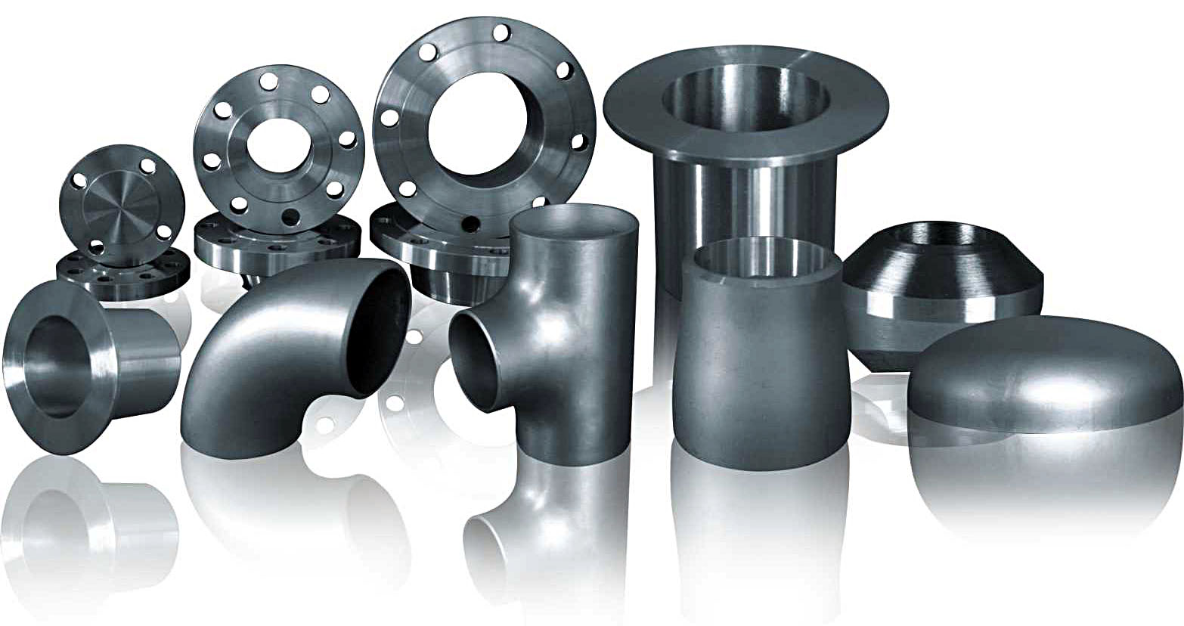

*Fittings*

1. **MATERIAL**
   1. **Nickel Alloy**
   2. **Titanium**
   3. **Austenitic Stainless Steels**
   4. **Duplex/Super Duplex Steels**
   5. **Prec. Hardened Stainless Steels**
   6. **Martensitic Stainless Steels**
   7. **Low Alloy**

Our strengths are extremely special products like **Nickel Alloy** (Inconel 718, Inconel 625, Incoloy 925, Incoloy 800/800HT, Monel 400/K500, Hastelloy X, Hastelloy C-276, ...), **Titanium** ( Titanium Grade 1, 2, 3, 4, 5, 7, 9, 12), **Austenitic Stainless Steels** (Nitronic 50, Nitronic 60), **Duplex/Super Duplex Steels** (F44, F51, F53, F55, F57), **Prec. Hardened Stainless Steels** (15-5PH, 17-4PH), **Martensitic Stainless Steels** (9Cr, 13Cr, S13Cr, Maraging C250/300). These product lines do not exist in Vietnam market, 100% import from overseas. With a wide network with strong makers/manufacturers in EU/G7 countries, we – Super Material Co., Ltd. is confident to be a reliable supplier for your company.

|  |  |  |  |  |  |
| --- | --- | --- | --- | --- | --- |
| **Grade** | **Other Names** | **Specifications** | **Industrial Standards** | **Shape** | **Size Range** |
| Alloy 718 | Inconel 718 | API 6A718, AMS 5663, spec 100679283 | N07718, DIN2.4668 | Round bars | Dia 0.5" - 12" |
| Alloy 625 | Inconel 625 | ASTM B446, B564, AMS5666 | N06625, DIN2.4856 | Round bars | Dia 1" - 8" |
| Alloy 925 | Incoloy 925 | API 6A | N09925 | Round bars | Dia 0.5" - 9.5" |
| Alloy C276 | Hastelloy C276 | ASTM B564, B574 | N10276, DIN2.4819 | Round bars | Dia 0.75" - 7.875" |
| Alloy 660 | Gr.660B, Gr.660D | ASTM A453, AMS5731, AMS 5732, A286 | S66286, DIN1.4980 | Round bars | Dia 0.5" - 4" |
| Alloy 31803, 22Cr | F51, Duplex | ASTM A182, A276, A479, Norsok-M650 | 1.4462, F51 | Round bars | Dia 1.57" - 7.87" |
| Alloy 32760, 25Cr | F55, Super Duplex | ASTM A182, A276, A479 | DIN 1.4501, F55 | Round bars | Dia 0.5" - 11.50" |
| Alloy 32750, 25Cr | F53, Super Duplex | ASTM A182, A276, A479 | DIN 1.4410, F53 | Round bars | Dia 5.5" - 8" |
| Alloy 39277, 25Cr | F57, Super Duplex | 85 Ksi | UNS 39277 | Round bars | Dia 3.5"-7" |
| Alloy K500 | Monel K500 | 100248736-AK, FMS 19B7-F, ASTM B865 | DIN 2.4375 | Round bars | Dia 0.625" - 5.25" |
| XM-19 | Nitronic 50 | ASTM A276/A479, NACE MR0175 | S20910 | Round bars | Dia 1" - 8" |
| 9Cr |  | ASTM A29 | WS-801 REV N, H+T | Round bars | Dia 6", 7.5", 8.25" |
| 13Cr | INOX 420, AISI 420M, SUS420J1 | ASTM A276 | S42000 | Round bars | Dia 3" - 12.50" |
| S13Cr |  | 95 Ksi and 110Ksi | S41427 | Round bars | Dia 4" - 8.5" |
| Low Alloy 4140 | SCM 440 | AISI 4140 | SCM 440 | Round bars | Dia 2" - 5" |
| 15-5PH |  | AMS 5659, ASTM A564/A564M-13 | UNS S15500, W Nr. 1.4545, | Round bars | Dia 0.5" - 4.75" |
| 17-4PH | AISI 630 | AMS 5643T, ASTM A564/A564M-13 | UNS S17400, W Nr. 1.4542 | Round bars | Dia 0.5" - 7.5" |
| Alloy X | Hastelloy X | AMS 5754M, ASTM B572-06 | UNS N06002, W Nr. 2.4665 | Round bars | Dia 1.5" - 3.5" |

1. **APPLICATION**
   1. **Oil & Gas and Petrochemical**

Super Materials Co., Ltd. specializes in providing special steels widely used in the processing and manufacturing of equipment/parts used in Oil and Gas Drilling industry, as well as in Chemical plants and Petrochemical plants. Types of commonly used materials in this industry include Inconel 718/625, Incoloy 925, Monel K500 / 400, Low Alloy 4140, etc.

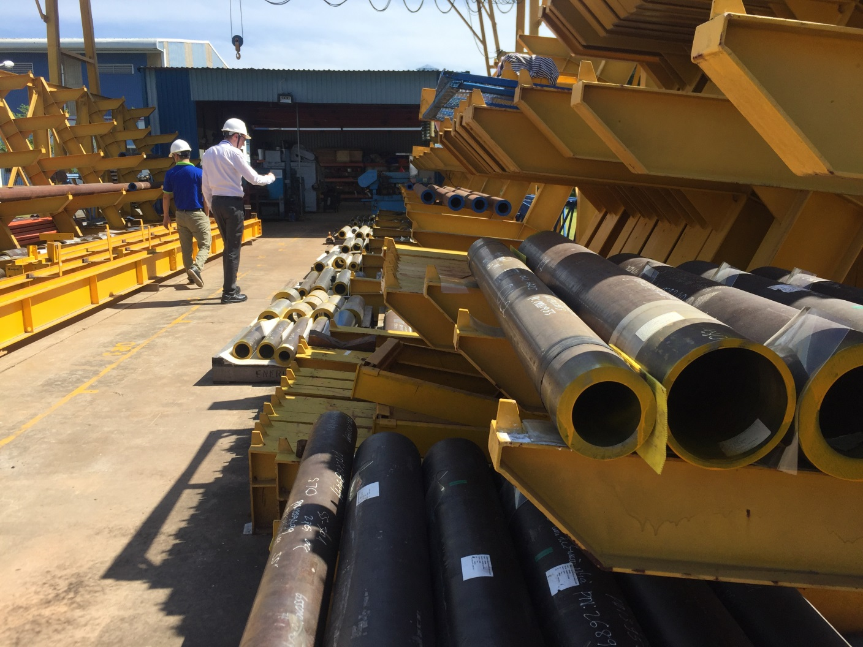

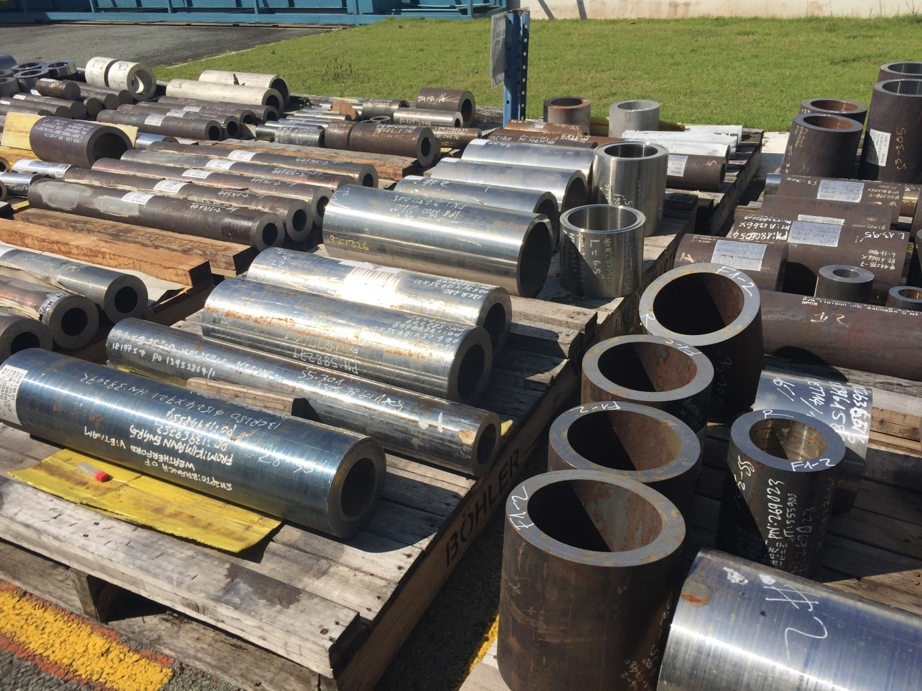

* 1. **Power Generation**

In the field of Power Generation, special materials are used to produce turbines, turbine blades, pump shafts, and associated parts. These materials are 13Cr, 9Cr, Super Duplex UNS S32750 / S32760, 17-4PH, etc.

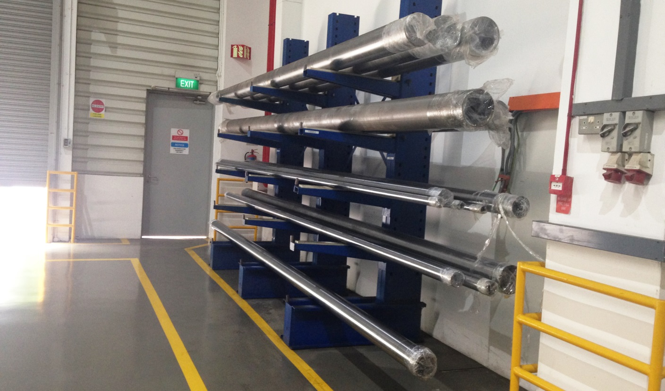

* 1. **Aerospace**

In the field of Aerospace, Inconel 718/625 materials and special stainless steel 15-5PH / 17-4PH in sheet form are commonly used to produce aircraft engines and related parts.

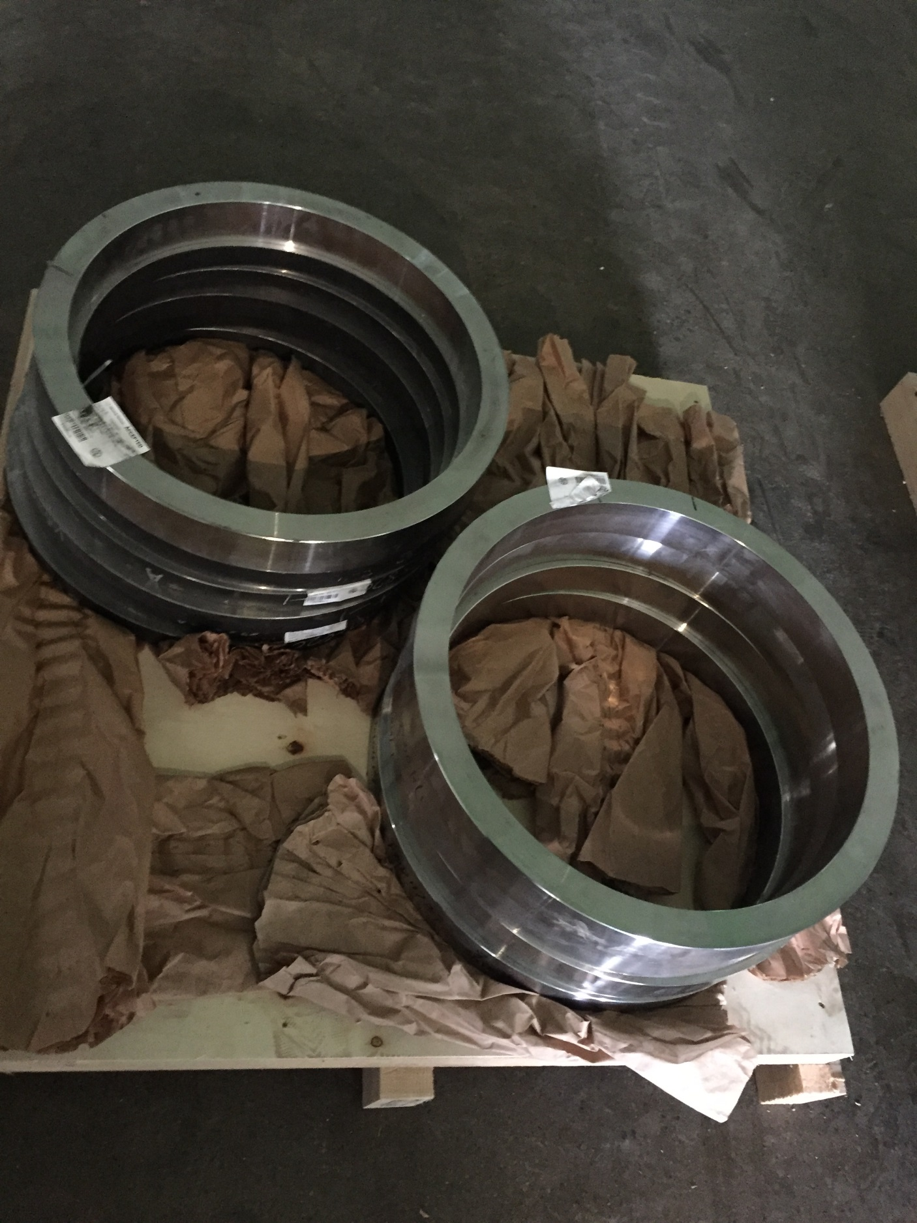

1. **OUR PARTNERS**

Saying NO to goods originating from China as well as India and aiming to bring the best prices to customers with guaranteed material quality, we - Super Materials Co., Ltd. has been cooperating in a variety of ways with manufacturers in EU and G7 countries. Our strategic partners include large corporations such as voestalpine, ATI, Carpenter, Bohler, Haynes Int., Nippon Yakin, Valburna, outokumpu, Special Metals, etc.

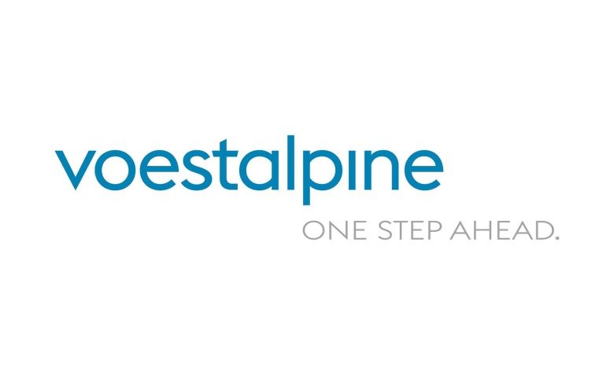









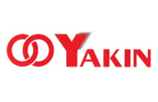



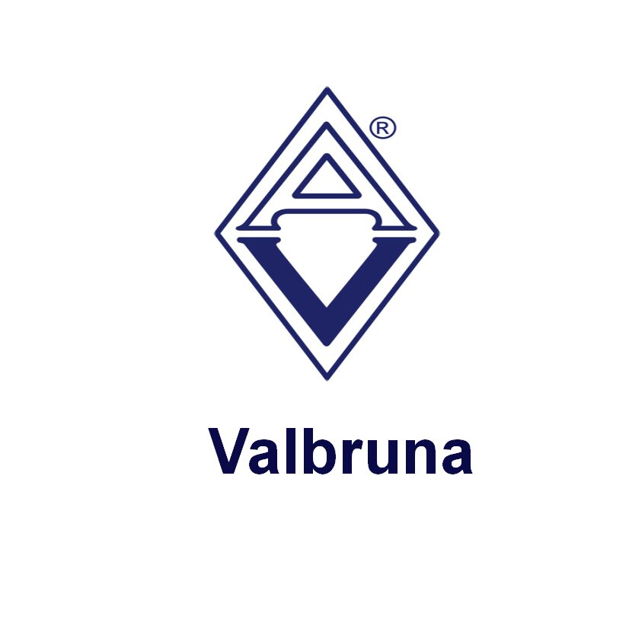

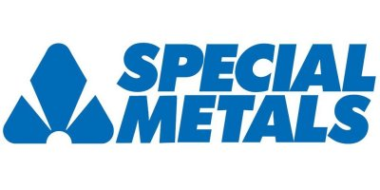

1. **OUR CUSTOMERS**

With many years of experience in importing and distributing special raw materials especially used in Oil & Gas, Energy, Shipbuilding and Engine Production / Aircraft Components, Super Materials Co., Ltd. has been providing various steels for enterprises who have production activities in the domestic market. Having a professional and flexible business team, our customers stretch from North to South in Vietnam territory.

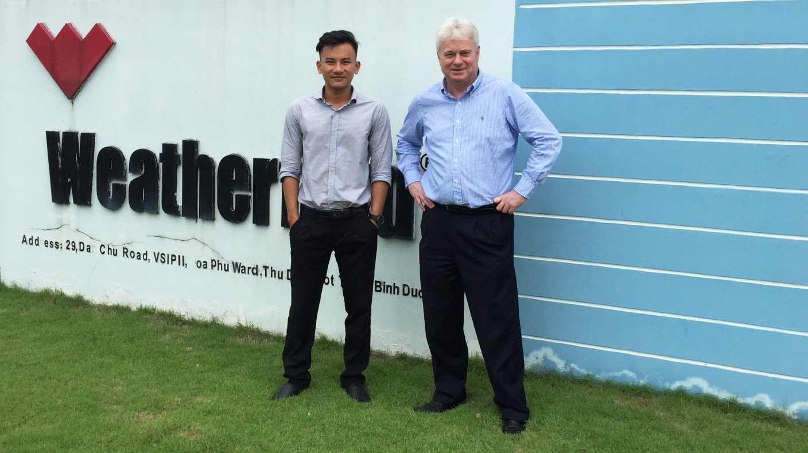

Super Materials Co., Ltd. visited Weatherford factory

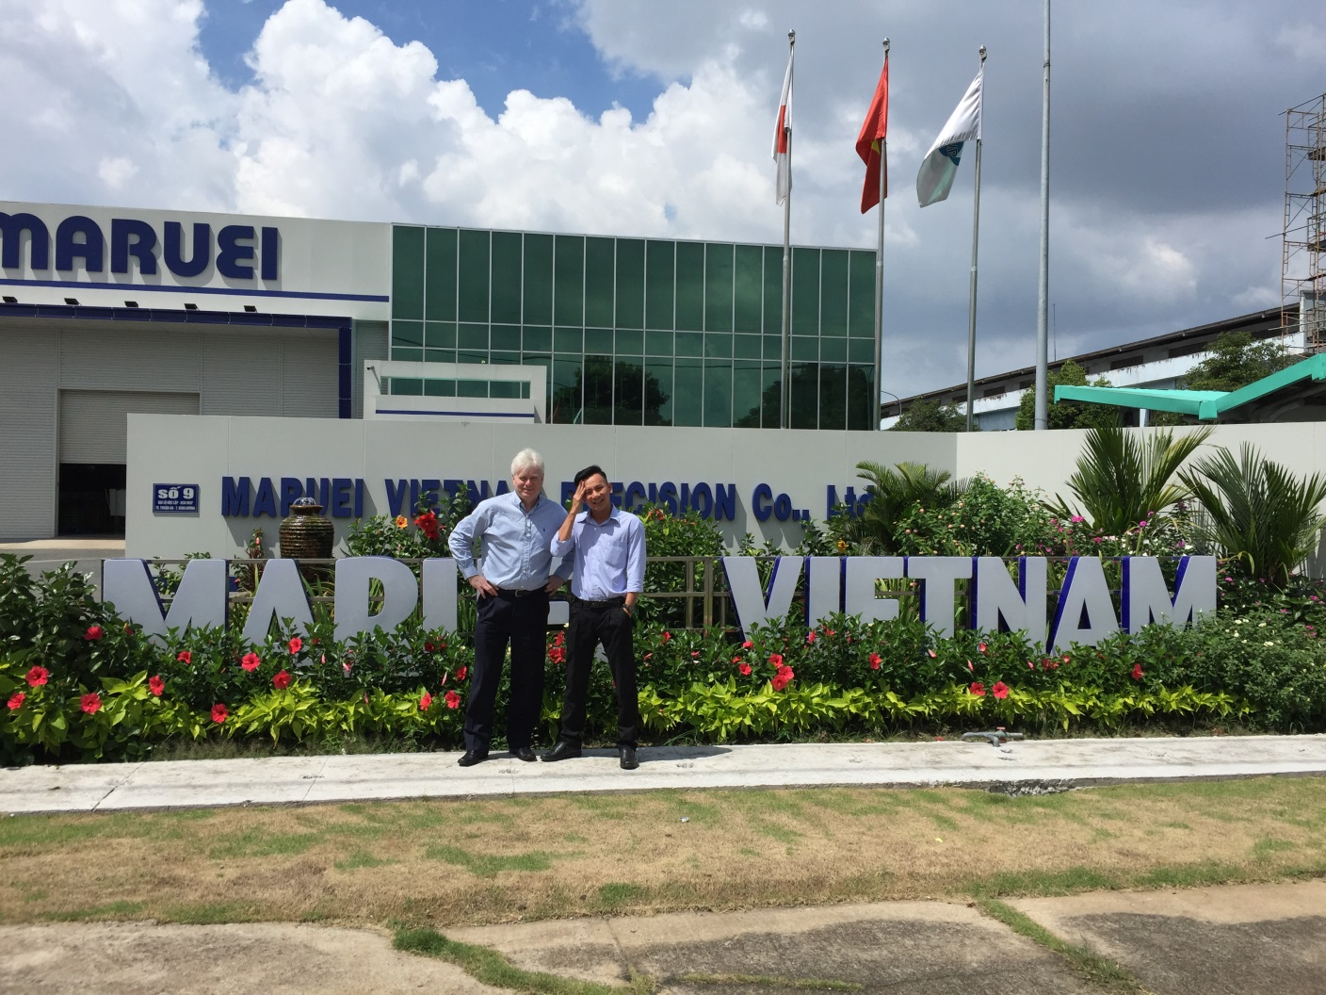

Super Materials Co., Ltd. visited Maruei Vietnam Precision factory

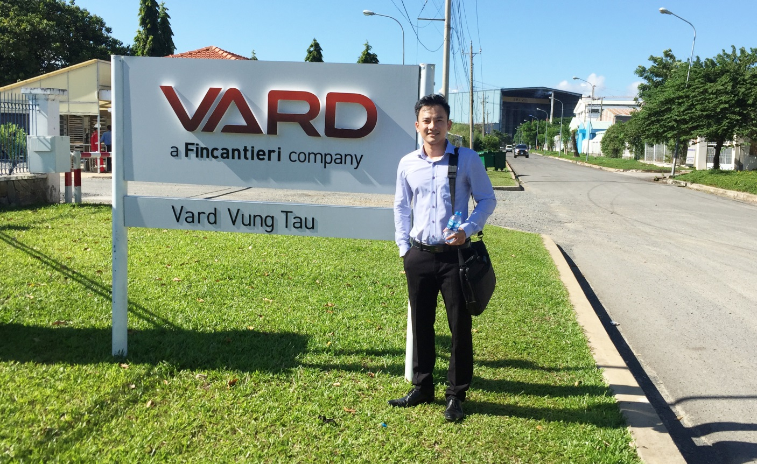

Super Materials Co., Ltd. visited Vard factory

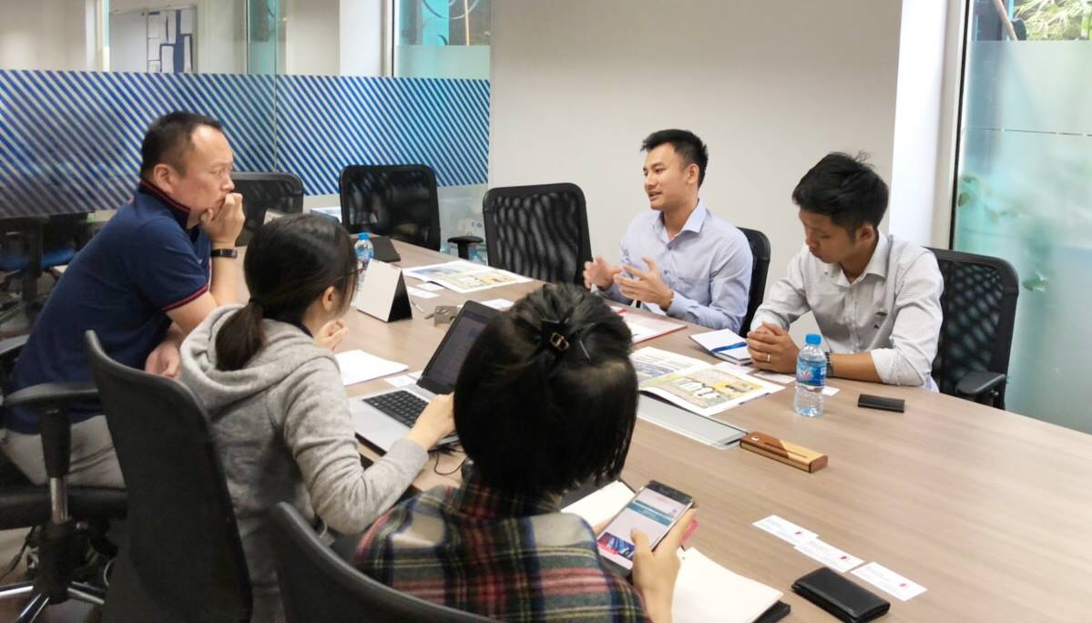

Super Materials Co., Ltd. visited and negotiated with Petroleum Maintenance Service Company

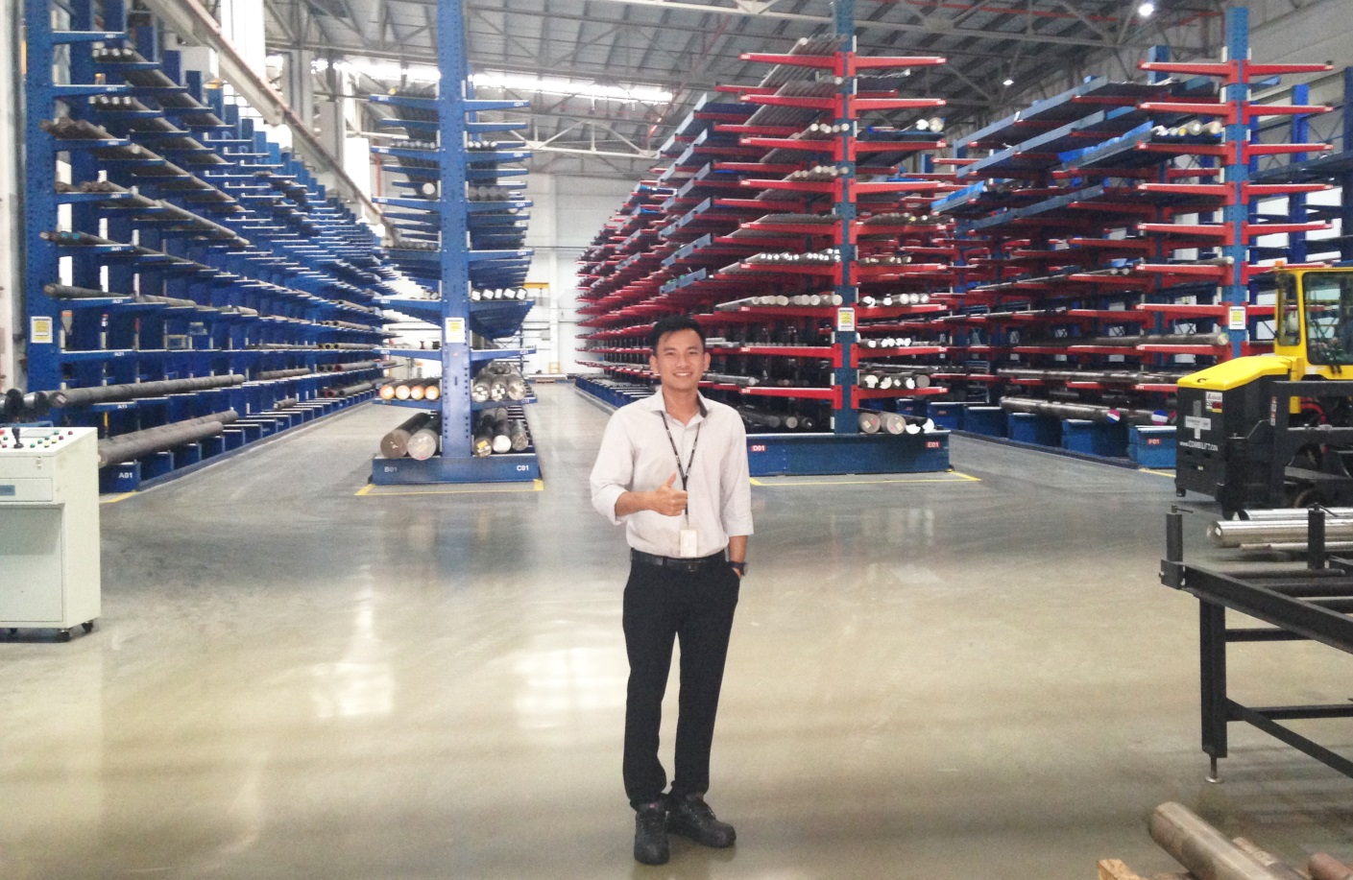

Super Materials Co., Ltd. visited voestalpine warehouse

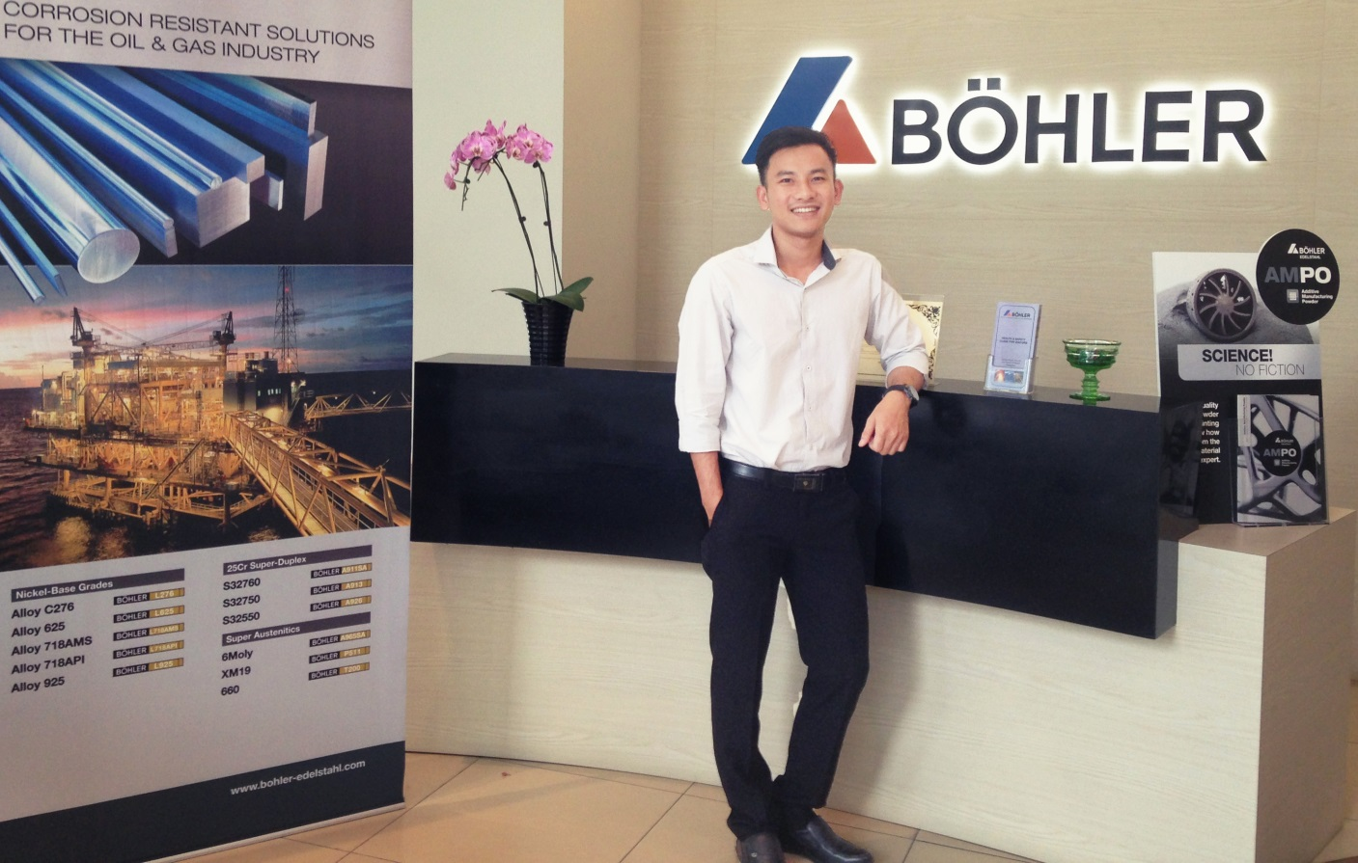

Super Materials Co., Ltd. visited Bohler and found the way to work together

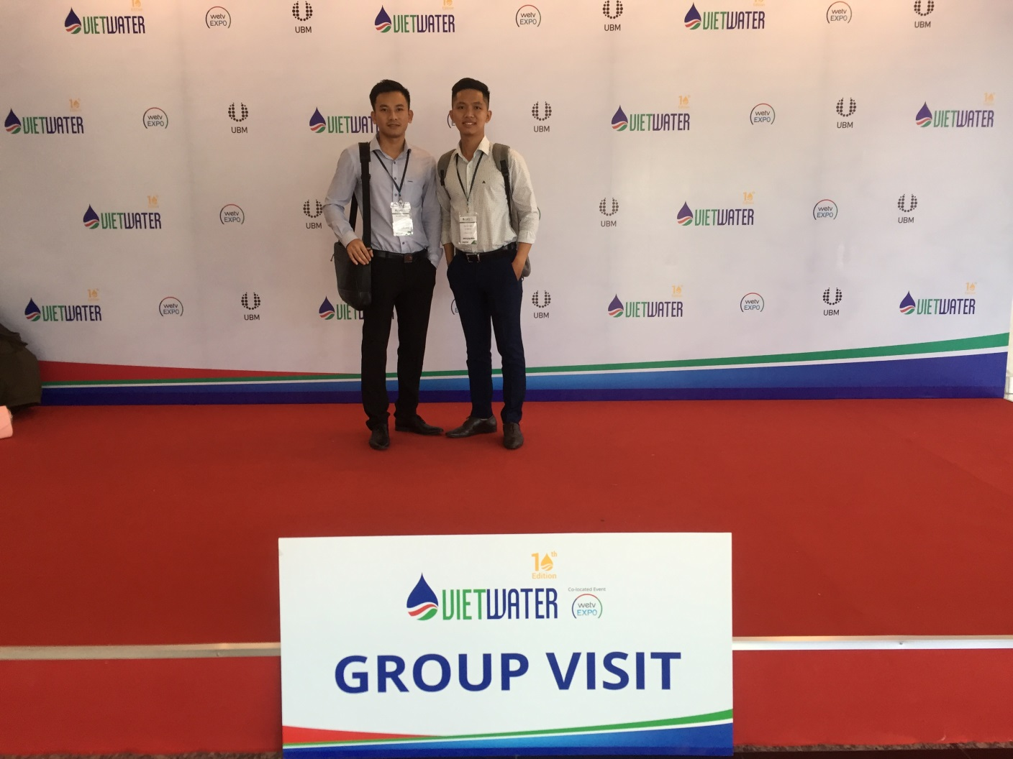

Super Materials Co., Ltd. attended International Exhibition VietWater 2018

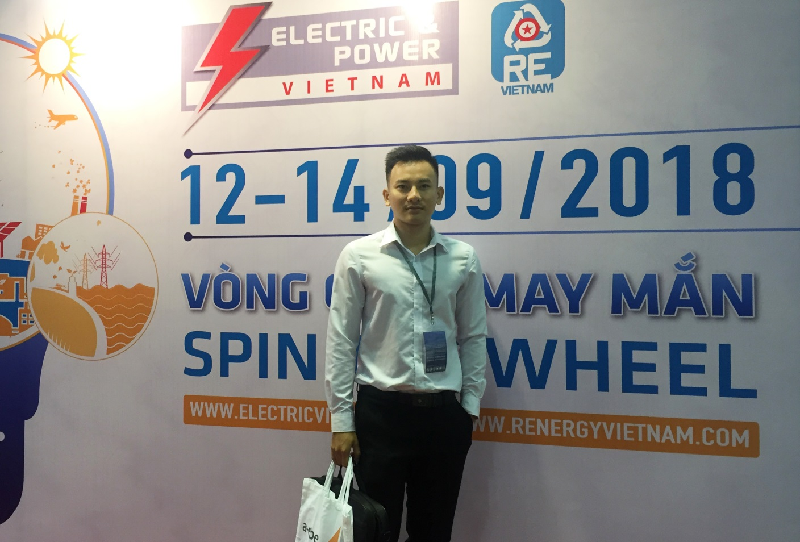

Super Materials Co., Ltd. attended Electric & Power Vietnam 2018 Exhibition

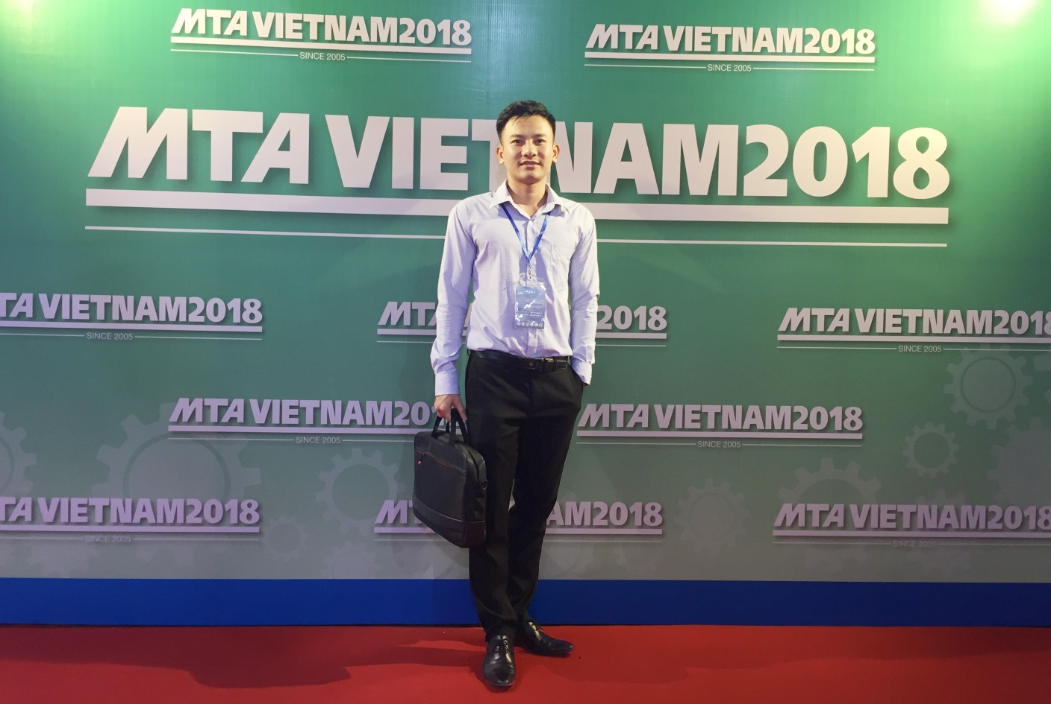

Super Materials Co., Ltd. attended International Exhibition MTA Vietnam 2018

1. **NEWS**
2. **CONTACT**

**SUPER MATERIALS COMPANY LIMITED**

Address: 201/15 Le Van Viet Street, Hiep Phu Ward, District 9, Ho Chi Minh City, Vietnam

Tax code: 0315502282

Phone: +84 98 9944 746

Fax: -

Email: sales@ss-materials.com (Mr. Nam)

Website: www.ss-materials.com